Sistemas Informáticos (Computer Systems)  
Unit 06. Windows administration - Part 2

short line

Authors: Sergi García, Alfredo Oltra

Updated November 2023

Licencia

**Reconocimiento - No comercial - CompartirIgual** (BY-NC-SA): No se permite un uso comercial de la obra original ni de las posibles obras derivadas, la distribución de las cuales se ha de hacer con una licencia igual a la que regula la obra original.

Nomenclatura

A lo largo de este tema se utilizarán diferentes símbolos para distinguir elementos importantes dentro del contenido. Estos símbolos son:

📖 **Important**

❕ **Attention**

💬 **Interesting**

**INDEX**

**1. Introduction 3**

**2. System properties 3**

**2.1 Advanced system settings 3**

**2.2 Device manager 6**

**3. Security management 7**

**4. Disk Management 8**

**5. Msconfig 9**

**6. Additional material 11**

**7. Bibliography 11**

Unit 06. Windows administration - Part 2

# Introduction

In this part, we continue studying Windows operating system. It’s mandatory to read and understand previous class notes to continue with part 2.

# System properties

In this video, you can watch several ways to go to “System properties” in Windows 10

<http://www.isunshare.com/windows-10/6-ways-to-open-computer-or-system-properties-in-windows-10.html> The most common way to arrive is right click on “This PC” and then in properties.

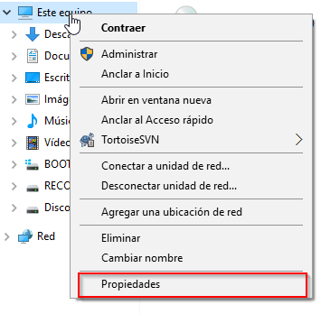

System properties is a menu where we can check our system specs like CPU, RAM, Windows version, etc.

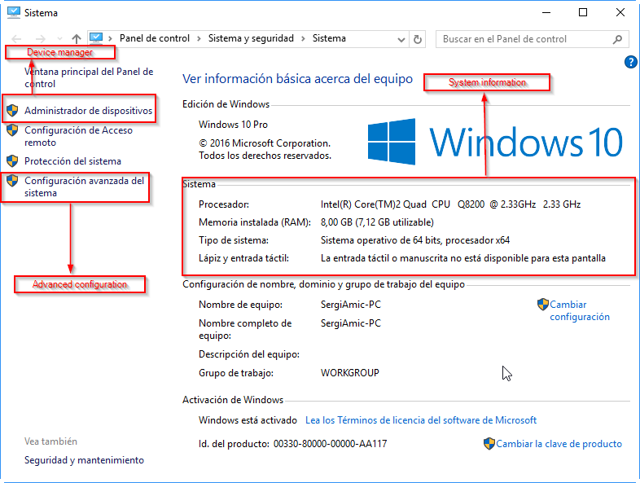

We are going to study two sections of System properties: “Advanced system settings” and “Device manager”

## Advanced system settings

In “Advanced system settings” we have several tabs, each one with a lot of options to modify.

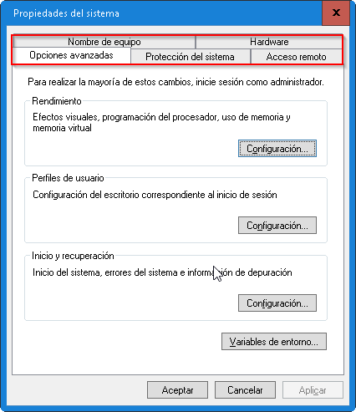

The most important functions are:

**Tab “Advanced options”**: you can configure several things, like user profiles, start and recovery, performance and environment variables.

Most important features are: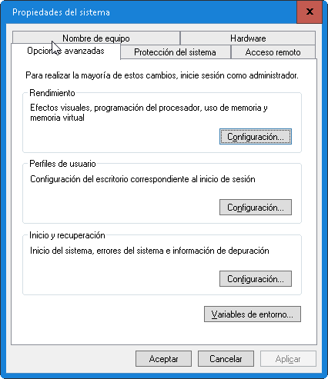

* **Performance**: you can configure how many resources uses your desktop (for example, deactivating effects for low computers) and configure how your system uses virtual memory.
* **Environment variables**: there you can define environment variables. It is useful to configure a lot of applications, like development environments.

**Tab “System protection”**: you can configure things like “System restoration”. We recommend do not use system restoration (Disable it) and use other programs to make backups of your system, like “Clonezilla” <http://clonezilla.org/> .

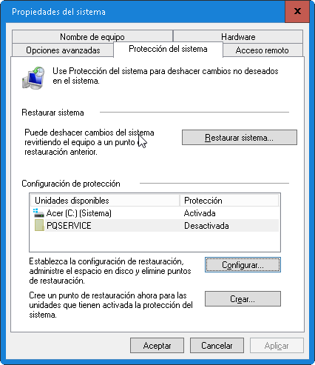

**Tab “Computer name”**: you can change computer name, and also you can configure your Windows to be in a workgroup or to join a domain.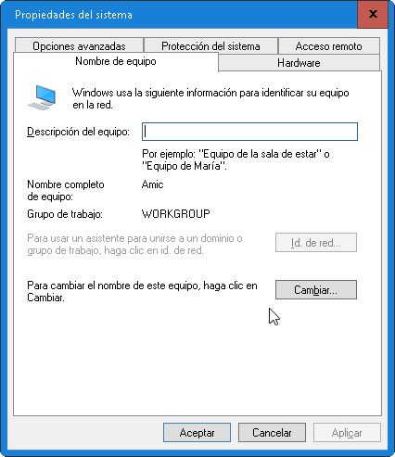

**Tab “Remote access”**: there you can configure if you can receive remote assistance (for example, to receive support through Internet).

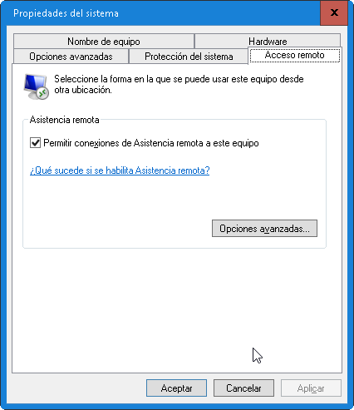

**Tab “Hardware”**: you can access to device manager and run a manager to add new devices.

## Device manager

Device manager is a menu to manage devices of our computer. In this Video, you can watch several ways to go to “Device Manager” in Windows 10 <https://www.youtube.com/watch?v=nEyQMq7bwlY>

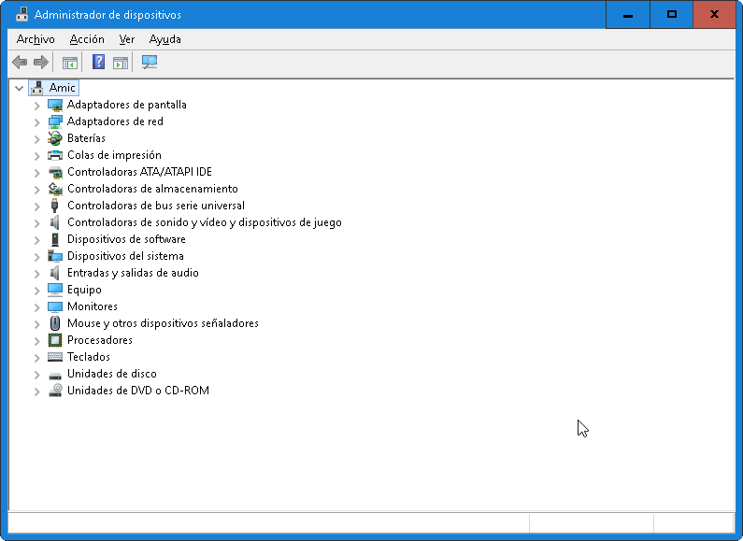

Basic management is explained in <https://www.youtube.com/watch?v=kXIDFUlWUDs>

The main operations that we can do are:

* Enable/Disable a device: useful when a component is causing trouble.
* Update driver of a device.
* Check state of a device.
* Uninstall components: several times are useful to uninstall a device to run again Windows auto-configuration. It can solve a lot of problems.
* Some devices let you do an advanced configuration (Example, configure energy saves in a Wi-Fi device). Those features depend on the installed driver.

# Security management

Windows 10 has several tools related to security. We are going to explain the most important tools available:

* **BitLocker**: BitLocker is a utility to cipher hard disk information. In this video, you have information of how to use BitLocker to cipher a hard disk <https://www.youtube.com/watch?v=nLh0jSfv6jA>

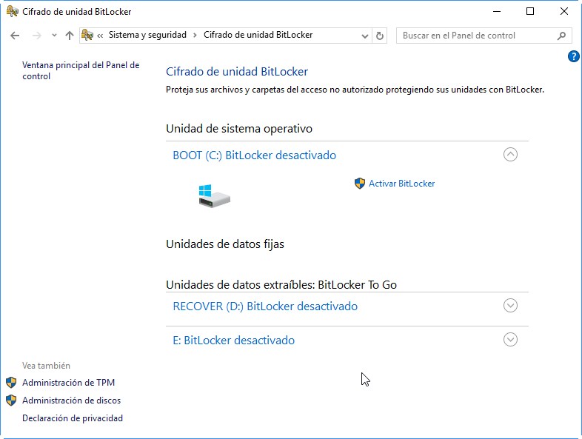

* **Firewall**: a firewall is a tool that monitors connections in our system and decides if a connection is accepted or denied. Firewall could be enabled or disabled.
  + In this video, you can watch how to enable/disable firewall on Windows 10 <https://www.youtube.com/watch?v=QhbzE6EBCno>
  + In this video, you can watch how to add a rule on the firewall <https://www.youtube.com/watch?v=2AcqibSJ8ng>

❕ **Attention** If you have problems with a connection, the first step you have to do is disable your firewall to confirm if it is the problem.

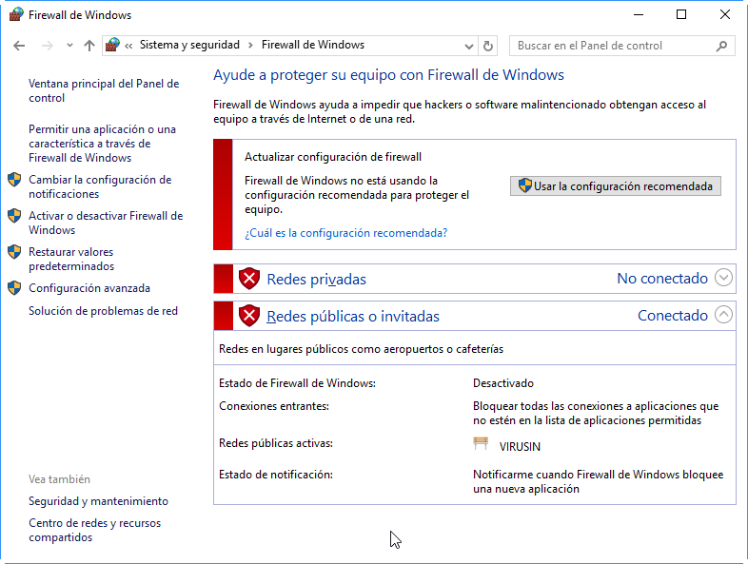

* **Windows defender**: Windows defender is an antivirus created by Microsoft. Nowadays is a good alternative to other products like AVG, Avast, ….
  + To use it properly, you have to update virus databases and periodically run a scan.
  + In this video, you can watch how to run a scan <https://www.youtube.com/watch?v=dy7rHgPcbQc>

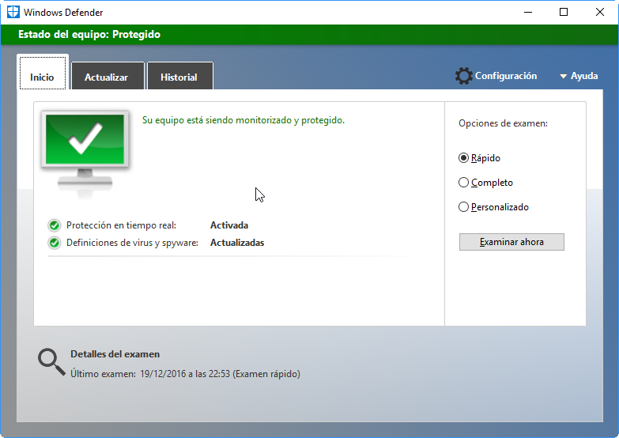

# Disk Management

Disk management is menu to manage hard disk of our computer.

In this Video, you can watch several ways to go to “Disk Management” in Windows 10.

<http://www.isunshare.com/windows-10/7-ways-to-open-disk-management-in-windows-10.html>

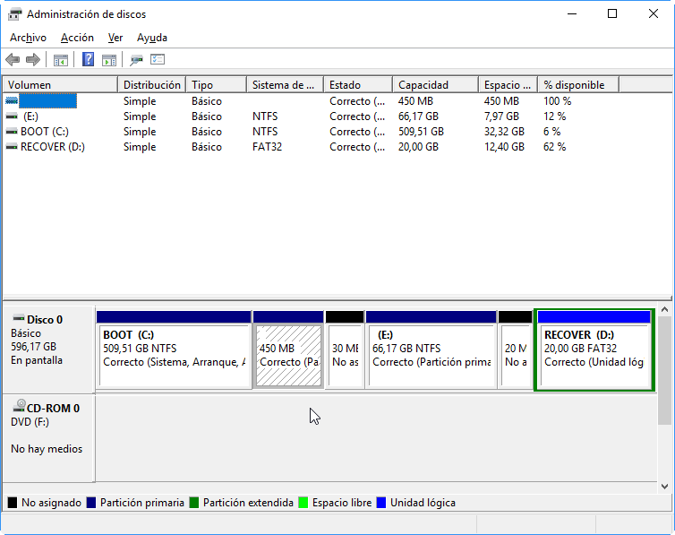

* Disk management has several important operations like:
  + Create/Delete a partition.
    - In this video, you can watch how to create a partition <https://www.youtube.com/watch?v=f8WzSRQ2NtY>
  + Shrink/Expand a partition.
    - In this video, you can watch how to shrink and how to expand a partition <https://www.youtube.com/watch?v=tJiakVgAtn4>
  + Create and manage Virtual Units (a file that works as a virtual unit).
    - In this video, you can watch how to manage Virtual Units <https://www.youtube.com/watch?v=gDLtOehX7NQ>

# Msconfig

Msconfig is a place where you can configure several things related with Windows 10 startup.

There are several ways to run Msconfig. The most common way is going to “Run” (Windows key + R) and type “msconfig”.

In this video, you can watch other method to access to Msconfig <https://www.youtube.com/watch?v=D0X29Jt2CKY>

Msconfig has several tabs:

* **General**: you can select how to boot your system (complete, diagnosis) or select which components load.

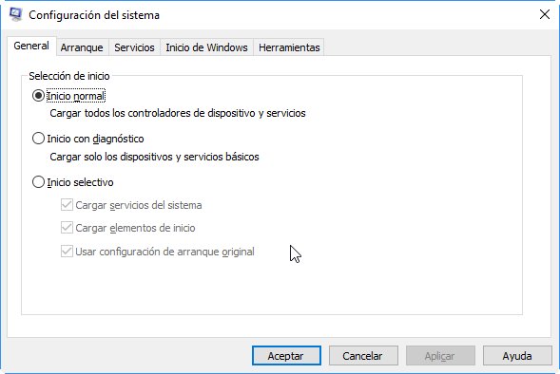

* **Boot**: you can configure Windows 10 boot manager.
* **Services**: you can select services that will be started automatically when you start your computer.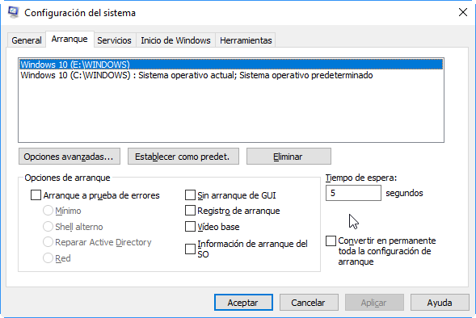
* **Start**: you can enable/disable applications that run when Windows starts.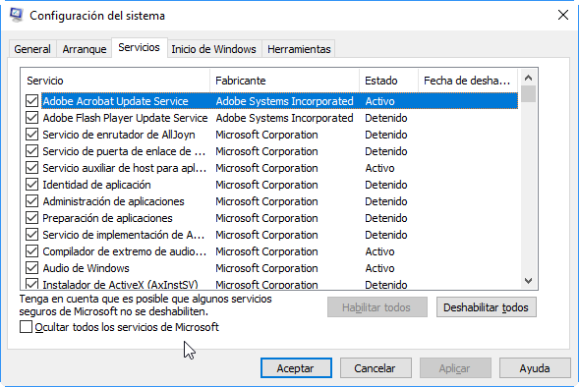

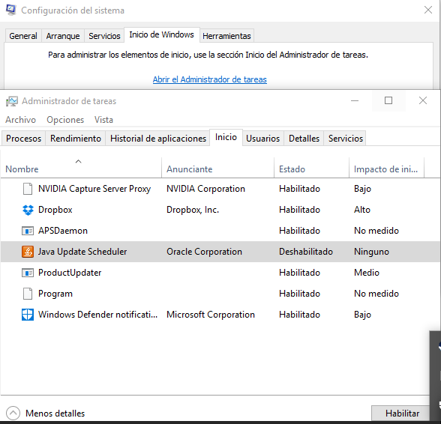

* **Tools**: you can use this tab as a shortcut to several system tools.

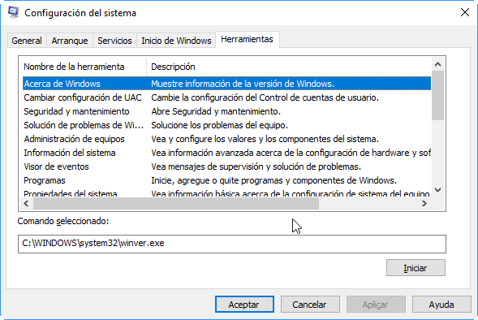

# Additional material

[1] Windows Training <https://learn.microsoft.com/es-es/training/courses/browse/>

# Bibliography

[1] Windows 10 <https://en.wikipedia.org/wiki/Windows_10>

[2] Microsoft support <https://support.microsoft.com/>